CpE 3110/CS3803 Homework Assignment #3 Maximum – 100pts

You must always show or explain your work in a neat and orderly format. You are encouraged to discuss ideas with other students and consult references, but your work must be your own.

Be sure to show your work/derivation for full credit (or maximum possible partial credit, if your final answer is not right). Also, do your best to maximize your HW score, since 13% of your semester letter grade will be decided by your HW/quiz performance.

1. Add two 4-bit unsigned binary integers 1011 and 1101. What are the 4-bit sum and carry-out bit? Does it cause an overflow? Justify your answer. [10pts]

2. Add two 4-bit signed binary integers 1011 and 1101. What are the 4-bit sum and carry-out bit? Does it cause an overflow? Justify your answer. [10pts]

3. Use the multiplication hardware and control algorithm shown below to multiply two 5-bit binary numbers 11010 and 11101. Note 5-bit input words are given instead of 32-bit words for the sake of simplicity. Construct a table to show: 1) values in Multiplicand, Multiplier and Product registers, and 2) Description of each step made. [20pts]

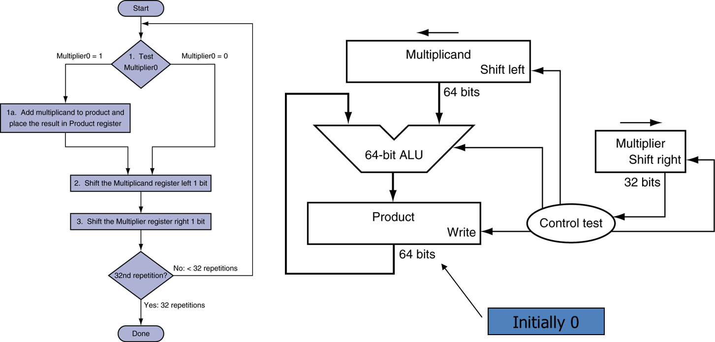

4. Use the optimized multiplication hardware shown below to multiply two 5-bit binary numbers 11010 and 11101. Note 5-bit input words are given instead of 32-bit words for the sake of simplicity. Construct a table to show: 1) values in Multiplicand and Product registers, and 2) Description of each step made. [20pts]

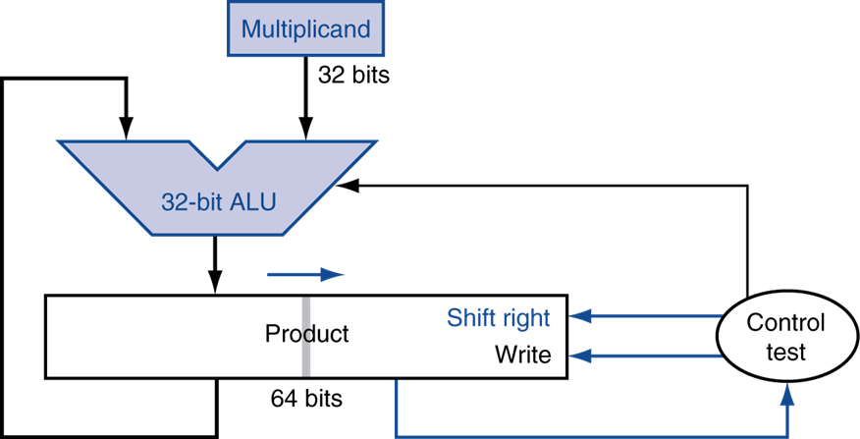

5. Find both single-precision and double-precision IEEE-754 floating point representations in binary for -15.25 in decimal. [20pts]

6. Add the following single precision floating point numbers and show each and every step [20pts]:

0 1000 0001 1010 1110 0000 0000 0000 000
0 1000 0000 1010 1010 0000 0000 0000 000

